**Name: MUTESI Jeannette**

**Reg: 221023554**

**Class No: 60**

**Group:2**

**Project Name: ATM System**

1. **PLANNING**

This project ATM System ,ATM in full word is Automated Teller Machine, and the definition ATM System is the system that will help the users withdraw money from their Bank with only their ID number of the bank account and pin set this is our goal and objective to help the people in getting their money in easily way.

This system always work easy 24/7

**The benefits of using ATMs:**

* the ability to access it in 24 hours (any time, any where.)
* you should use it any where you are and you get your money.
* it is user friendly.
* it will help the users making money quick payments with its accessibility.

**The problems this system will solve:**

* Wastage of time (waiting on the lines at bank)
* Wastage of money and time in transport
* Insecurity

1. **DESIGN**

The way of our system? Basically, we want to access information of the users within the bank’s database after

1. **DEVELOPMENT**

In Development Faze, we used java language and MYSQL and Database. In java we used NetBeans program as the compile and it help us to make the interface of our system ,in the case of connecting we used the MySQL connector ,which will help us to access to the Mysql Database ,So we used SQL language to access and interact with our Database as the Storage of our data.

**In General we used this following techniques:**

* NetBeans in java and designing interface
* Mysql connector
* Mysql Database
* Sql language.

1. **TESTING**

On this faze we will show you, how our system works .

***Login page***

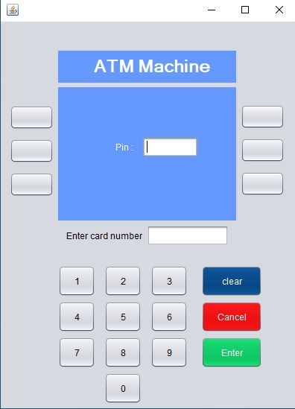

***Withdraw***

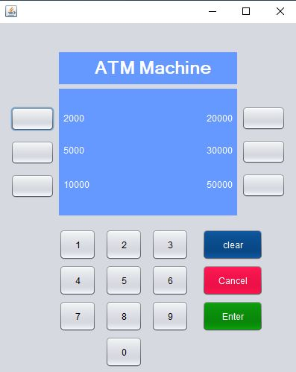

***Checking Balance***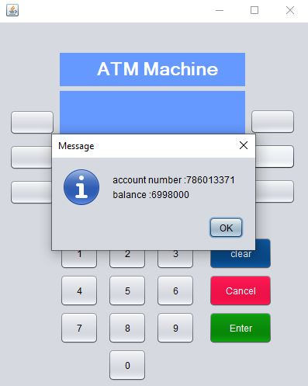

***Home***

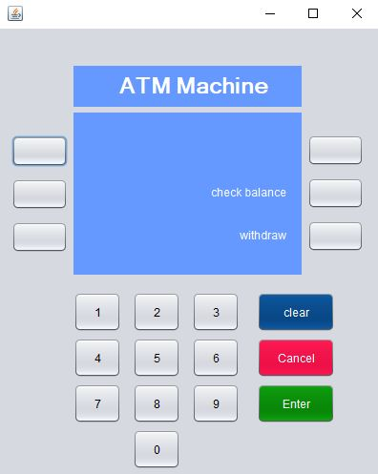

1. **DEPLOYMENT**

On this faze Deployment we will connect our system to the Bank users database first with the application will have database in which users will find their information to log into the system, After connecting ,we will test the security and then we share it to users through their smartphones.